Chapter 14 Generics and the ArrayList Class

- Generics: type parameter enabled coding
  - applies to any class
- ArrayList
  - container that can grow and shrink
  - has private instance variable: Array
    - when Array is full, new larger Array is created and data is transferred
  - less efficient than Array
  - syntax
//BaseType can not be primitive type
ArrayList<BaseType> aList = new ArrayList<BaseType>();

//intial capacity of 20 items
ArrayList<BaseType> aList = new ArrayList<BaseType>(20);

aList.add(“something”);
int howMany = aList.size();
aList.set(index, “something else”);//replace index
String thing = aList.get(index);
boolean hasString = aList.contains(“something”);
aList.remove(index);
aList.clear();
  - can be used with for-each
for (String entry: aList)
System.out.println(entry);
  - ArrayList grows automatically but does not shrink automatically, so use trimToSize to save memory
  - clone method makes a shallow copy
  - Vector class is almost same as ArrayList, but ArrayList is newer and prefered
- generic class (or parameterized class)
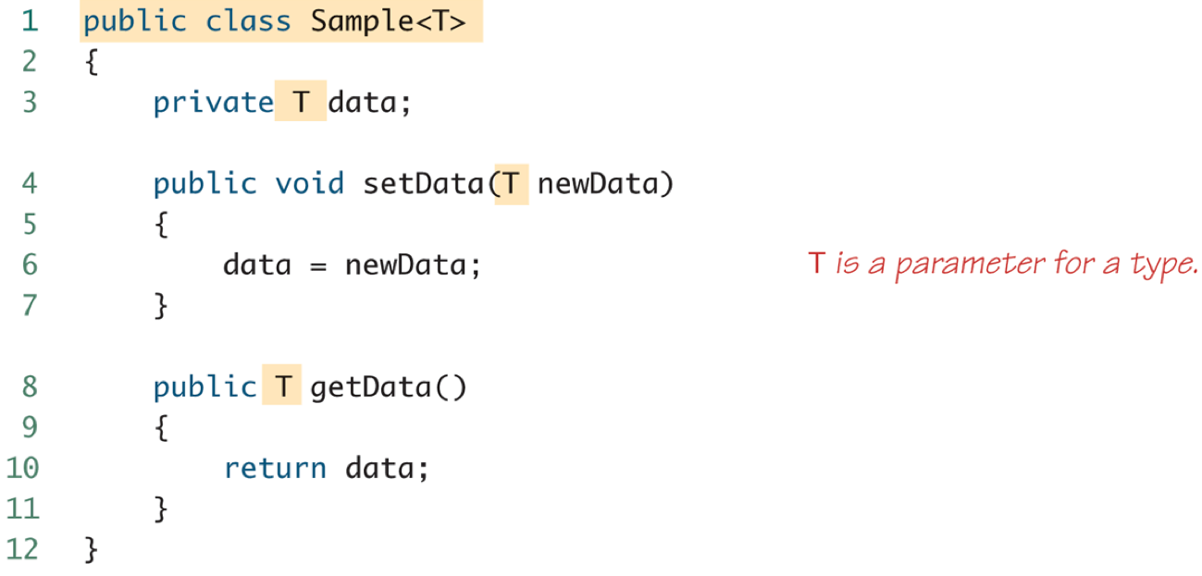
  - definition: class definition with type parameter
  - type parameter is included in angular brackets(<>) after the class name in the class definition heading
  - type parameter no needed to be included in the constructor
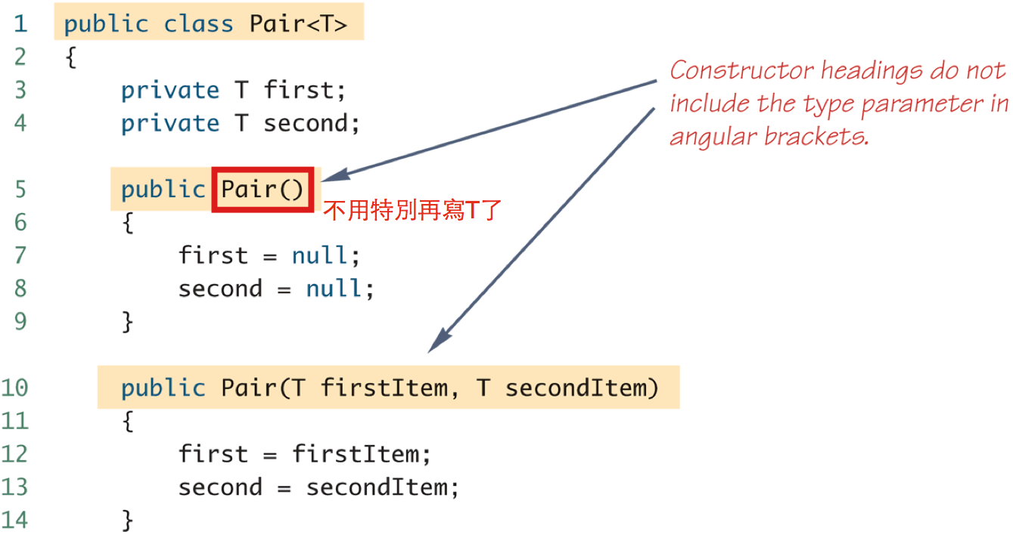
  - type parameter cannot be used in expressions to create a new object當別人使用這個class的時候，必須要指定好型態！
T object = new T(); //illegal
T[] a = new T[10]; //illegal
  - generic class cannot be an Array base type
Pair<String>[] a = new Pair<String>[10];
  - multiple type parameters
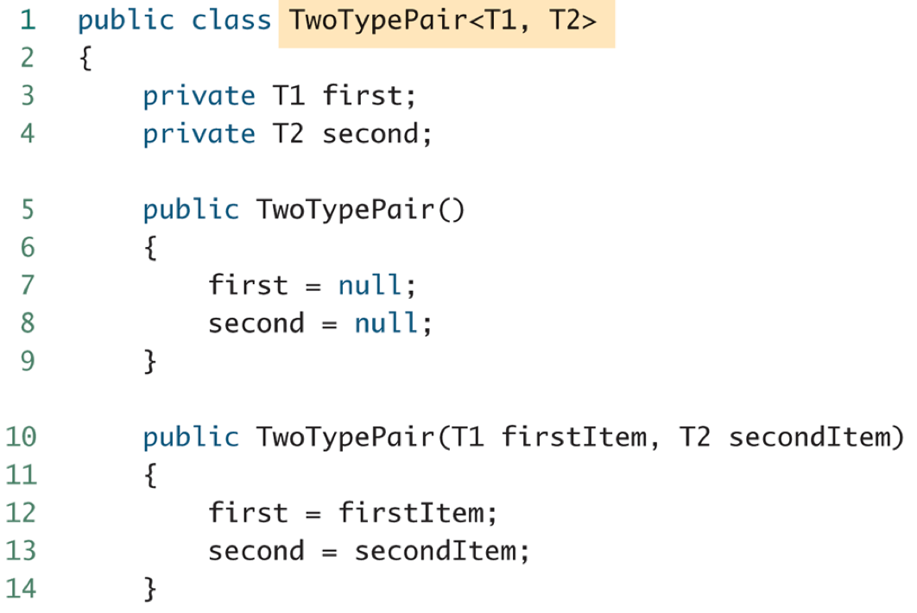
  - generic class cannot be an Exception class
public class Pair<T> extends Exception //illegal
  - bounds for type parameters
    - restricting the possible types that can be plugged in for T
public class RClass<T extends Comparable>
public class ExClass<T extends Class1>
public class Two<T1 extends Class1, T2 extends Class2
& Comparable>
//不可以class & class，因為Java沒有多重繼承！
- generic methods
  - definition: type parameter used in the definitions of the methods for an ordinary class or a generic class
  - type parameter of a generic method is local to that method, not to the class
  - syntax
public static <T> T genMethod(T[] a) //<T>和T順序不可以錯！

String s = NonG.<String>genMethod(c);
- inheritance with generic class
